* My Github Account Name: littlesnail1982
* My Design Pattern:

Command:

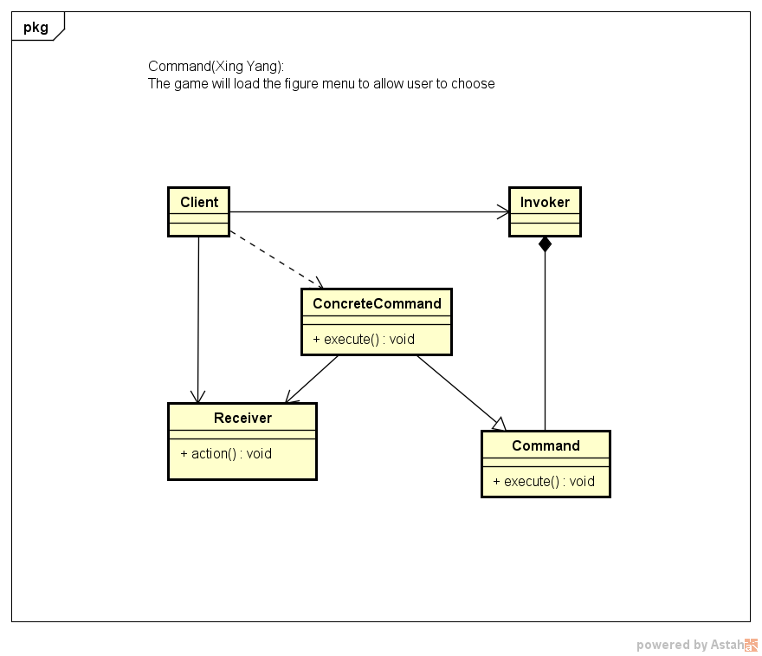

* The XP Core Value I am Advocating:

Simplicity: This week, we extend the work to four enemies. Except for the basic move and punch actions, we add the healthy bar to show the strength of the figures. We also add the death conditions for each figure. For example, one enemy will die if he is hit for 6 times. We have not considered any weapons for figures yet. Except that, we still use fix background for every level. We begin to replace the dummy figure images with the real figure images step by step. We begin to refactor the code with some design patterns. For example, we begin to extract the scenes setting to a template, different level may have different setting numbers in the template. We also try to apply different strategies to figures like the figure will have different number of lives, the figure could have weapons (for example, stars) when his blood above some value, or the move speed will get lower and lower when his strength getting weaker and weaker. If we still have time, we may allow the user to choose hardness of the playing, like easy, medium or hard. We had two discussions this week, and we decided that we don’t add enemies any more, only keep at most 5 enemies, according to our schedule, we may not make the background move any more. Try to make a workable and fluent game is the most important thing.